Subjective Questions
Q1) What is the relation between patient wait time and satisfaction scores?
Answer:
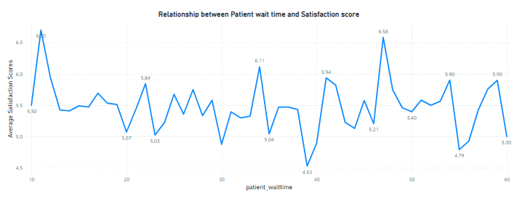
Insights:
- From the above visual we can understand the relationship between patient wait time and satisfaction score.
- We can observe that the satisfaction score is mostly uniform during the period of wait time but highest satisfactory score is obtained during the 10 mins wait time (6.70) and lowest around 40 mins (4.53).
- The ratings might not be accurate as 75% of the ratings were missing and analysis has been made on the basis of remaining 25%, so the hospital should also encourage patients to provide the ratings so that the accurate analysis can be made.
Approach used:
- Scatter chart was created using the wait time column and average satisfaction score measure.
- Average satisfaction score measure was used because the 75% of the ratings data is null so to make the analysis remaining 25% data was used to make somewhat accurate analysis.

Q2) How do patient demographics affect the frequency of visits to different departments?
Answer:

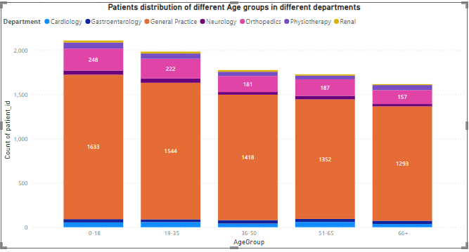

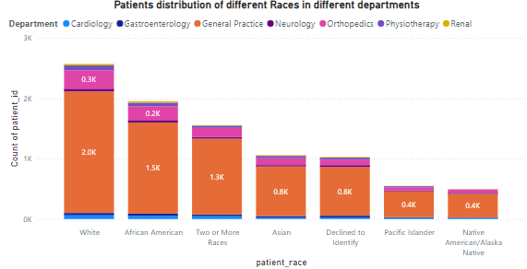
Insights:
- From the visuals we can observe the distribution of patients in the departments on the basis of their age and race.
- This will help in understanding the demographics of the patients.
- This will also help in improving the facilities on the basis of the observations.

Approach used:
- Stacked column chart was created for observing the distribution of patients.
- Columns department referral, age group, race and count of patient id were used for the charts.
Q3) Is there a noticeable trend in the volume of patient visits throughout the year?
Answer:
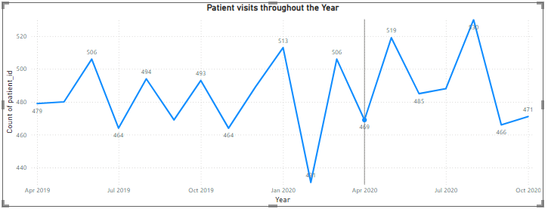
Insights:
- From the visual we can observe the visits of patients throughout the year.
- Patients visits peaked on August 2020 (530).
- Least number of patients visited on February 2020 (430).
- The trend cannot be analysed as the data is inconsistent which affects the analysis.

Q4) Which age groups report the highest and lowest satisfaction scores?
Answer:

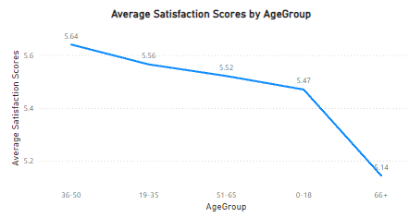

Insights:
- From the visual we can observe the satisfaction score for different age groups.
- Line chart was created using the average satisfaction score measure and age group column.
- Age group 36-50 reports the highest satisfaction score (5.64).
- Age group 66+ reports the lowest ratings (5.14).

Q5) Say someone outside of the hospital claims that there is racial or gender-based discrimination in the hospital, how will you identify whether the claim was right or not?
Answer:
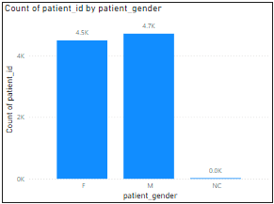
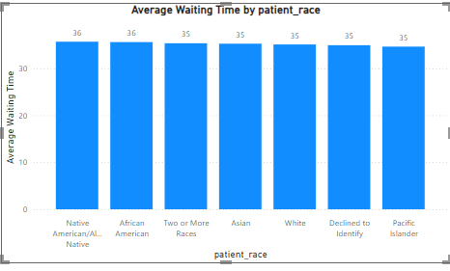

Insights:
- From the above visual of patient distribution patients, we can observe that the number of male and female patients does not have significant difference between them.
- From the visual average waiting time by patient race we can clearly observe that all the races have similar waiting time indicating that no race is being treated differently.
- This clearly indicates that the medical care is provided irrespective of the gender and race and there are no signs of racism and gender inequality in the hospital.

Q6) The hospital management intends to offer discounts to patients. How should these offers/discounts be assigned to patients, on what basis, and why?
Answer:
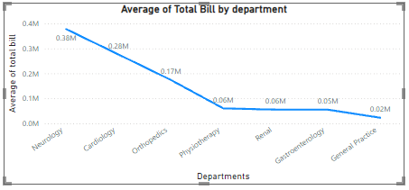

Insights:
- From the visual we can observe the revenue generated from each department.
- Neurology (0.38M) and Cardiology (0.28M) are the highest revenue generating departments indicating higher number of patient visits.
- From the previous analysis we had observed that neurology has the highest appointment fee i.e., (1500)
- Considering all the factors, we can provide discounts to the patients from neurology and cardiology departments.

Q7) The hospital has a budget to hire 2-3 new doctors. They have asked for your suggestions on which departments they should hire.
Answer:

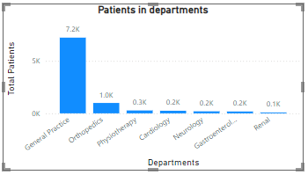
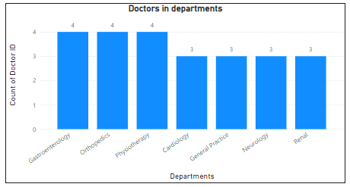

Insights:
- From the visual we can see the number of patients in different departments.
- General Practice (7.2K) has the highest count of patients followed by Orthopedics (1.0K).
- Renal (0.1K) department has the lowest number of patients.
- Considering all the factors new doctors should be hired in the departments with higher number of patients.
- So, doctors should be hired in General practice, Orthopedics and Physiotherapy department.
- General Practice only has 3 doctors tending around (7.2K) patients, so the doctors should be hired in this department.

Q8) Is the hospital profitable? How will you determine the profitability?
Answer:
- Appropriate data like doctor salary, maintenance costs and faculty salaries are not available to conduct the analysis.
- Only the revenue generated can be calculated but not the operational costs.
- So, the analysis cannot be conducted.

Q9) Any Department for which the waiting time is oddly large?
Answer:

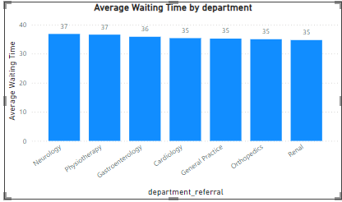
Insights:
- From the visual we can observe average wait time in different departments.
- Almost all the departments have similar wait time.
- So, no department has oddly large waiting time.

Q10) Come up with strategies to provide discounts to the patients.
Answer:
- As previously mentioned in question 6, neurology and cardiology department are the highest revenue generating departments and they also have high appointment fees.
- So, they are appropriate departments to provide discounts.
- Medical campaigns can be started in which during certain days discounts can be provided which would also help in getting more patients.
- This would help in maximizing the profits and would be beneficial to hospitals and also people could access healthcare facilities in affordable prices.

Q11) Say you need to align the doctors of the “General Practice” department to work in one of the two shifts, how will you identify what will these two shifts' timings be, and how will you divide the doctors in these two shifts? And also, will this 2-shift policy be helpful for the hospital?
Answer:
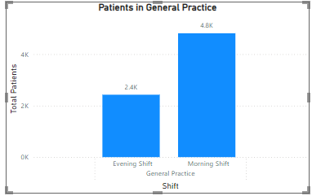

Insights:
- From the visual we can observe the distribution of patients on the basis of timings that is morning or evening.
- Morning shifts (4.8K) have more patients than evening shifts (2.4K).
- From the previous analysis we had observed that general practices department only have 3 doctors which would be hectic for doctors as the workload would be much higher for 3 doctors and they could not work efficiently.
- So, new doctors should be hired and they should be split in different shifts so that the doctors can have enough rest and could work efficiently.
- 2-shift policy would definitely be helpful in the medical field a bit of negligence can cost the life of an individual so by introducing this policy doctors can have enough rest and it would help them in working efficiently.

Q12) What do you understand by Power BI gateway? What are its use cases?
Answer:
- A Power BI Gateway is a bridge that facilitates secure data transfer between on-premises data sources and the Power BI service (cloud).
- It allows users to access on-premises data without moving it to the cloud.
- The gateway provides secure and seamless integration for data refreshes, ensuring that cloud-based Power BI reports and dashboards are up-to-date with the data residing on local servers.
Use cases:
- Scheduled Data Refresh
- Real-Time Data Access (Direct Query)
- Access to On-Premises Data
- Sharing and Collaboration with On-Premises Data

Q13) How would you approach this problem, if the objective and subjective questions weren't given?
Answer:
If the guidelines were not provided following would be my approach:
- Firstly, I would have cleaned the data, i.e., I would have checked whether all the columns had appropriate data types.
- I would have addressed the missing values and would have used appropriate methods to deal with them and also would have created a separate date and time columns for efficiency.
- Then I would have created a separate table to store all the measures created for better efficiency.
- Then I would have created basic metrics, analysing them and then use them for further analysis.
- I would have created charts accordingly to the business requirements such as doctors in different departments, revenue generated by each department and many more.
- Then I would have compiled all the necessary visuals to create an informative report.

Q14) Can you analyse and write the type of relationship between the doctor id and department, is it one-to-one?
Answer:
- No, doctor id and department does not have one to one relationship.
- Relationship between doctor id and department is one to many.
- Because multiple doctors may work in the "General Practice" department, but each doctor is typically assigned to just one department at a time.

